UNDERGRADUATE OFFICE

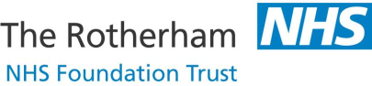

APPLICATION FORM

APPLICATION FOR A MEDICAL STUDENT ELECTIVE ATTACHMENT
AT ROTHERHAM NHS FOUNDATION TRUST

Please apply at least 3 months in advance of requested start date

NAME
EMAIL

TELEPHONE NUMBER

MEDICAL SCHOOL
CURRENT YEAR ON COURSE
DATES REQUESTING | From:
 | To:
Is there any flexibility with your requested dates? | YES / NO * * Delete as appropriate  If Yes, please give details:
SPECIALTY OR SPECIALTIES INTERESTED IN
ANY SPECIAL NOTES:

SUBMIT

rgh-tr.medundergrad@nhs.net

