E-Expenses on E-Roster
Please contact e-roster@rothgen.nhs.uk to get your user name for your account.
There is a user guide available, user guide for when making and approving claims.
You must attach copies of all receipts.
All claims must follow the Trust Policy.
For claims are paid from PGME and not the division i.e Dental, GP and Foundation Trainees and SAS Doctors
- Login in. You must be internet explorer not chrome
- Click on expenses on the top index
- Click on New Claim
- Change your approving unit to Postgraduate Medical Education
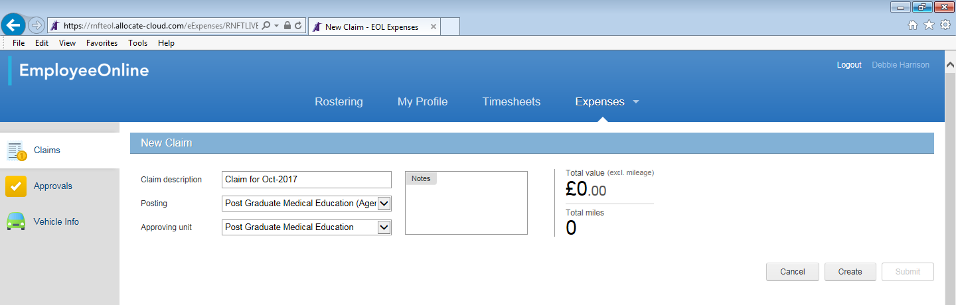
- Press create. This will allow you to enter multiple entries for this month.

Claiming Mileage

If you are claiming mileage, you must register your car with Greyfleet. www.greyfleet.com You will be asked to provide a number of documents about your car.
Please note to claim mileage you must have business insurance on your car.
- First of all create a new claim for that month, if required.
- Click on Mileage
- Click on New Expense
- Complete the following information:
- Description i.e. course title
- Expense type – Business Mileage
- Date – date of mileage
- Using – chose your vehicle
- Tick if you were carrying passengers
- From – enter Home, Base or starting post code
- To– enter Home, Base or starting post code
- Tick if this is a straight forward return trip
- The system will then work out the mileage of the journey and then the amount you can claim.
- If this is the only journey you are claim on this day, click save. If you want to add another journey on another day, click save and new.
- If you have multi journeys on the same day, click add trip. This will start your trip from your last destination.

Other Travel
To add other forms of travel, i.e. train
Each item must be added separately.
- First of all create a new claim for that month, if required.
- Click on travel
- Click on New Expense
- Complete the following information:
- Description i.e. course title
- Expense type – Business Travel
- Date – date of travel
- Amount
- From – enter address
- To– enter address
- Tick receipt available
- Click Add Images. You MUST upload a copy of your receipts. This can only be uploaded as a jpeg
- Press Save or Save and New

Subsistence
Each item must be added separately.
- First of all create a new claim for that month, if required.
- Click on Subsistence
- Click on New Expense
- Complete the following information:
- Description i.e. course title
- Expense type – Evening Meal Allowance etc
- Date
- Amount
- Tick receipt available
- Click Add Images. You MUST upload a copy of your receipts. This can only be uploaded as a jpeg
- Press Save or Save and New

Other Expenses
For course fees and parking expenses. Each item must be added separately.
- First of all create a new claim for that month, if required.
- Click on Supplementary
- Click on New Expense
- Complete the following information:
- Description i.e. course title
- Expense type – Parking, course fee, etc
- Date
- Amount
- Tick receipt available
- Click Add Images. You MUST upload a copy of your receipts. This can only be uploaded as a jpeg
- Press Save or Save and New
Submitting a completed claim
You can add more than one type of expenses to your claim.
Once you have added all your expenses, press submit.

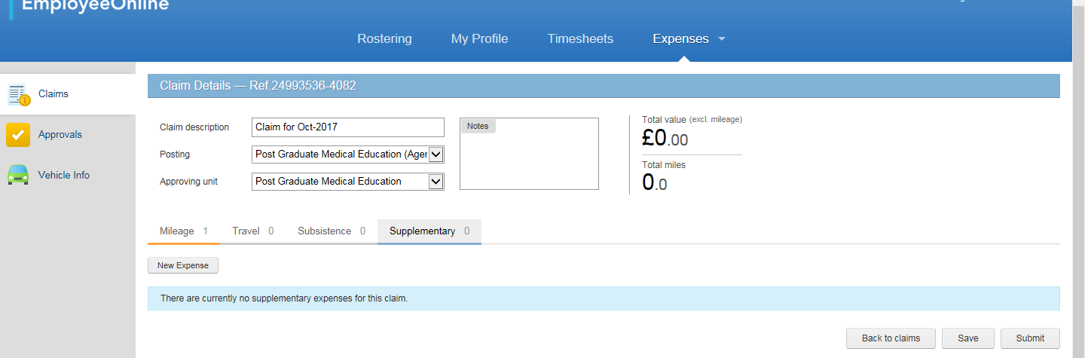

This claim will now move to your Submitted Claims folder.
Once approved, it will move to Sent for Payment.
