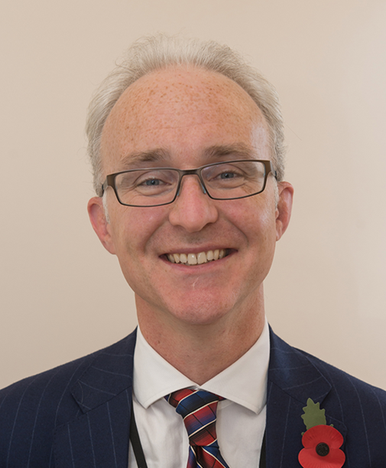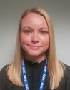 Medical Undergraduate Newsletter

Rotherham NHS Foundation Trust

**STAFF NEWS (Part 1):**

**PHASE 2&4 UNDERGRADUATE LEAD**

**Mr Chitakattil Oommen has been appointed as Rotherham’s Undergraduate Lead for Surgery wef 01/02/20. He joins Dr Kathryn Goddard, Undergraduate Lead for Medicine. Together they oversee and advise on issues relating to the Phase 2B (1st clinical year) and Phase 4 (final year) student attachments**

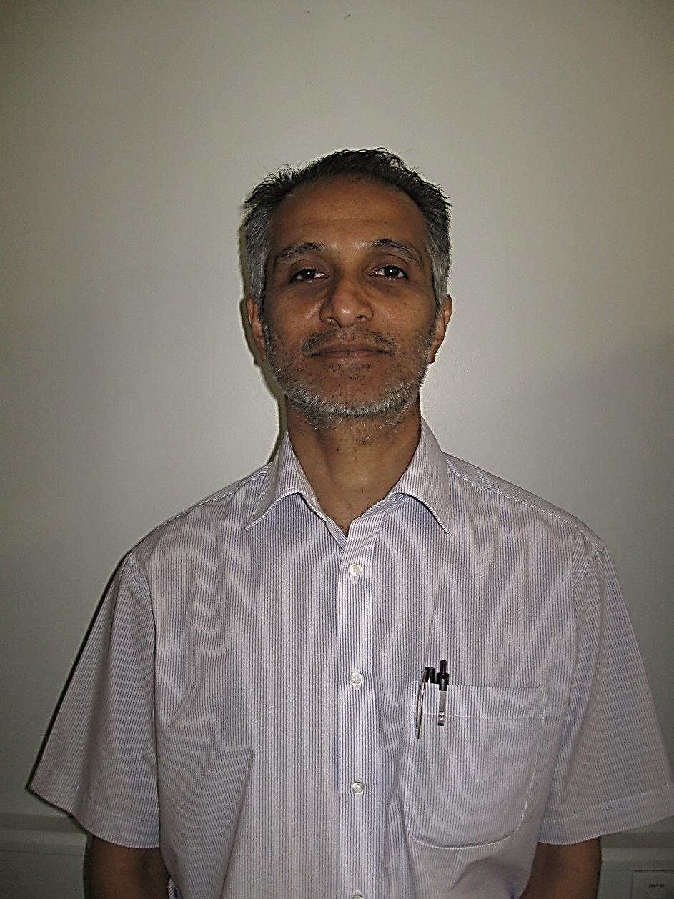

**PHASE 3A CHILD HEATH UNDERGRADUATE LEAD**

**Following Dr Muhammad Khan’s departure from the Trust, Dr Sundhar Kanagasabapathy will be taking on the role of Child Health Undergraduate Lead**

Issue **02**

April 2020

## J0198113

## MEDICAL SCHOOL NEWS – COVID 19

Following a Faculty Emergency Planning Meeting on 16/03/20 where information and discussions coming from national bodies, including Medical Schools Council (MSC) were reviewed, Sheffield Medical School took the decision to suspend all face to face teaching and clinical placements.

**THE KEY POINTS :**

1. **Phase 1 and 2** early years placements continue to be suspended, and

teaching is being delivered on line. Assessments will probably be done on-line

using a range of different formats including open book examinations, and will

only cover those elements the students have covered.

2. **Phase 3a and 3b** clinical placements suspended from 16/03/20 with

Modifications to in-course and end of phase assessments reflecting those

placement experiences students have missed.

3. **Phase 4:** clinical placements suspended from 17/03/20. Plans are in place with

the GMC to register final year students who have passed the requirements of

the course and they will enter the workforce earlier than August.

Further decisions will follow when the University, Public Health England, and the clinical situation nationally and locally evolves.

**This Issue**

**Staff News (Part 1) P.1**

**Medical Student Help P.1**

**Medical School News P.1**

**Staff News (Part 2) P.2**

**Early registration of final**

**year medical students & F1 doctors P.2**

**MEDICAL STUDENT HELP**

**Covid-19 Volunteering Scheme**

A number of medical students are willing to volunteer to help with the Covid-19 effort.

Any Doctors, Nurses and Healthcare workers that would like help can make a request using an online form, the link to which was circulated in a Trust Coronovirus Communication on Thursday 26/03/20. If you cannot access this form, please contact the Medical Undergraduate Office

**STAFF NEWS**

**(Part 2): DR SIMON McCORMICK RECEIVES CLINICAL TEACHING AWARD FROM SHEFFIELD MEDICAL SCHOOL**

Dr Simon McCormick has been

nominated as Top Trainer in

Rotherham for 2019. Simon

was due to be presented his

Clinical Teacher Award at the

November 2019 Medical

School event; ‘Medical

Education – A Sheffield

Update’, unfortunately, this

event was cancelled. The

event was re-scheduled to take

place in Chesterfield in March

but this was also subsequently

cancelled due to the COVID 19

situation. Due to current

circumstances, it is unclear

when this formal presentation

will be made, but we feel we

can no longer hold back with reporting this news and congratulating Simon.

The Clinical Teaching Awards were established by the Medical School as a formal way by which to recognise and reward excellent teaching provided by senior NHS staff. Awards are made to those in the NHS (not university staff) who have shown exceptional engagement in supporting students. Each year the medical students are asked to nominate individuals who fulfilled the following criteria:

* Has provided teaching of the highest quality within a clinical setting over a sustained period
* Inspires and supports students through close engagement with them and by being an excellent role model
* Enables students to feel part of their clinical team and enables other members of their team to help with their development
* Creates an environment in which students feel empowered to engage with clinical medicine.

Awards are made to NHS staff in General Practice, Psychiatry, each of the four Associate Teaching Hospitals and Sheffield Teaching Hospitals.

**Congratulations Simon!**

**Supporting the COVID-19 Response**

**Early provisional registration of final year medical students & F1 doctors**

**Key Points:**

- Final year medical students may apply to GMC for provisional registration at start of April 2020. Subject to confirmation by their medical school that they have graduated and that there are no fitness to practise considerations, they will be provisionally registered.

- Doctors who have sought and been granted provisional registration at an early stage in 2020 can be offered appointment as Foundation Locum Appointments for Training and will be known as **Foundation Interim Year 1** (FiY1) doctors. These are short term posts and doctors occupying these posts will become FY1s when they join their respective Foundation training programme in August 2020.

- Current F1 doctors may apply at the start of April 2020 to the GMC for full registration. Subject to confirmation from their Foundation School through the provision of a Foundation Year 1 Certificate of Completion that they have already met the requirements set out in Outcomes for Provisionally Registered Doctors; and that there are no fitness to practise considerations, they will be fully registered.

- F1 doctors who have applied for and being granted full registration by the GMC will remain in F1 placements in their current HSC Trust and will be able to undertake a broader range of duties. These doctors will be known as **Foundation Interim Year 2** (FiY2) doctors. These posts will last until August 2020 when they will move to take up their previously allocated F2 post and begin their 12month placement as a Foundation year 2 doctor.

THESE ARE VOLUNTARY

OPT-IN SCHEMES

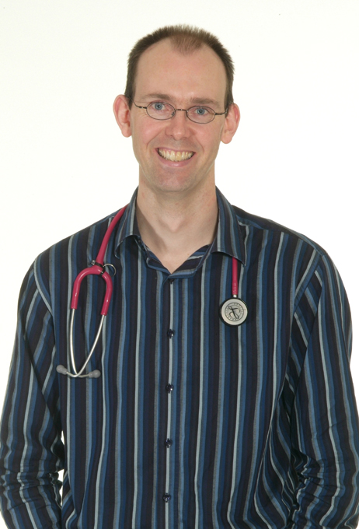

The Medical Undergraduate Team would like to say a HUGE thank you to all our NHS colleagues who are working flat out in these difficult times.

We hope you are all keeping safe and healthy

We do not know yet when the students will return on clinical

placements, but for the foreseeable future there should be a

member of staff available in the Undergraduate Office, while other staff

members of staff work from home. We are all available by email:

Kay Jaques: [kjaques@nhs.net](mailto:kjaques@nhs.net)

Sarah Hicks: [sarah.hicks11@nhs.net](mailto:sarah.hicks11@nhs.net)

Sarah Scott: [sarah.scott46@nhs.net](mailto:sarah.scott46@nhs.net)

**For more information about any of these articles or if you would like to submit a short article for a future issue please contact:**

[**kjaques@nhs.net**](mailto:kjaques@nhs.net)